HD 75732

HD 75732 is a 1.015 M☉, K0 IV-V star1. Based on 562 RV Lick data obtained between 1989 and 2010, 703 RV HIRES data obtained between 2001 and 2020 and 318 RV Apf data obtained between 2013 and 2019, the CL survey reported a Hot Jupiter (HD 75732b) signal with a period of 14.6517 ± 0.0001 days, a minimum mass of 0.841 ± 0.026 MJup and an eccentricity of ${0.0048}_{-0.0031}^{+0.0036}$, a second Hot Jupiter (HD 75732c) signal with a period of 44.383 ± 0.004 days, a minimum mass of ${0.171}_{-0.0067}^{+0.0066}$ MJup and an eccentricity of ${0.048}_{-0.029}^{+0.031}$, a LPGP (HD 75732d) with a period of ${4820.2}_{-72.1}^{+77.2}$ days, a minimum mass of 2.86 ± 0.25 MJup and an eccentricity of ${0.139}_{-0.016}^{+0.015}$, a GP (HD 75732e) signal with a period of ${260.98}_{-0.25}^{+0.23}$ days, a minimum mass of ${0.1475}_{-0.0094}^{+0.0093}$ MJup and an eccentricity of ${0.142}_{-0.066}^{+0.060}$ and a sub-Jovian mass planet (HD 75732f) signal with a period of ${0.736544}_{-0.000001}^{+0.000002}$ days, a minimum mass of ${0.0295}_{-0.013}^{+0.014}$ MJup and an eccentricity of ${0.036}_{-0.025}^{+0.034}$.

In the present study, in addition to the CL survey's dataset, 61 RV ELODIE data obtained between 1996 and 2005, 119 RV HRS data obtained between 2003 and 2004 and 88 RV HARPS data obtained between January and March 2012 were used. DPASS and MCMC (400 walkers and 800000 iterations) were used to fit the data. To converge more easily, the priors on the semi-major axis and the minimum mass of the planets b, c and f were close to the values found in the CL survey. The properties found for all the planets reported in the CL survey were within the error bars associated with the values found in the present analysis.

The fits are shown in Fig 1, and the corner plot in Fig 2, and the results summarized in Table 1.

Conclusion: The properties found in the CL survey for all planets are confirmed.

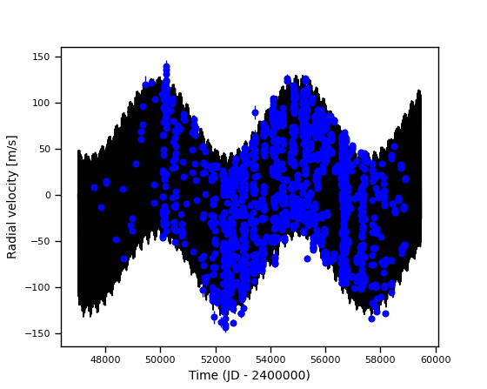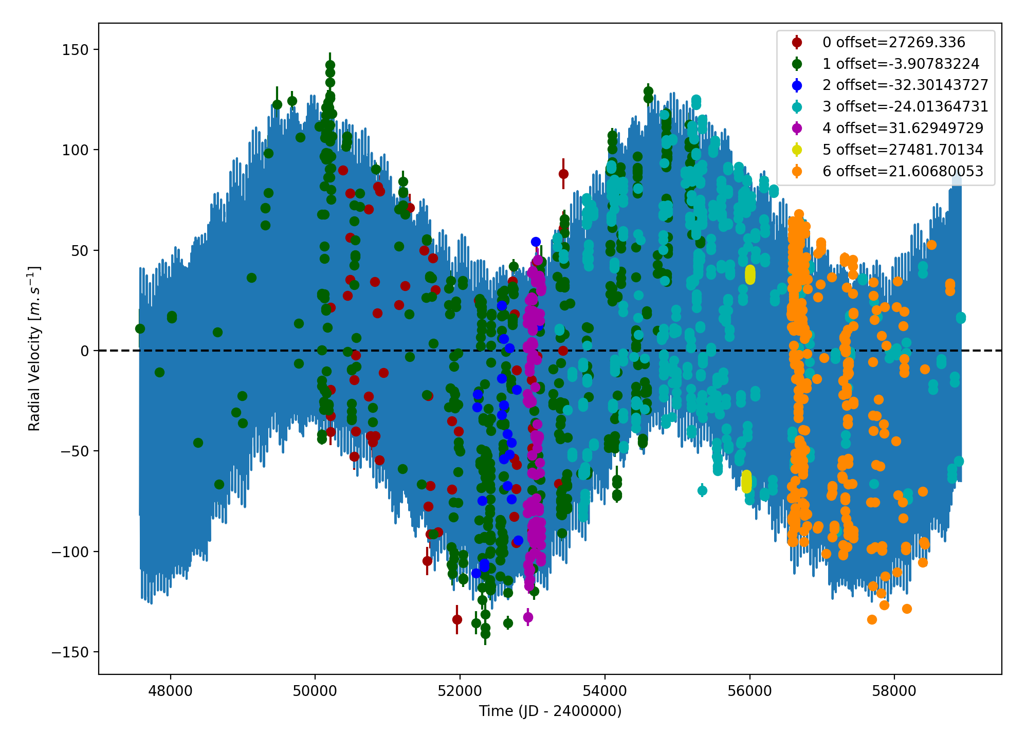

Figure 1: fit of HD 75732 RV with DPASS. Red - ELODIE, green - LICK, blue - Hir94, cyan - Hir04, purple - HRS, yellow - H03, orange - Apf. The blue curve shows the best fit. Right: fit of the HD 75732 RV using MCMC. The black curve shows the best fit.

| Parameter | Priors | | Posteriors | | CH survey |
| --- | --- | --- | --- | --- | --- |
|  | DPASS | MCMC | DPASS | MCMC |  |
| *a* (au) | b: [0.05,0.2]  c: [0.2,0.3]  d: [0,50]  e: [0.5,1]  f: [0.01,0.02] | b: [0.1,0.13]  c: [0.22,0.26]  d: [5,7]  e: [0.7,0.9]  f: [0.015,0.017] | b = 0.12  c = 0.25  d = 5.76  e = 0.8  f = 0.016 | b = 0.117 ± 0.001  c = 0.245 ± 0.001  d = 5.82 ± 0.04  e = 0.80 ± 0.01  f = 0.016 ± 0.001 | b = 0.1162 ± 0.0018  c = ${0.2432}_{-0.0039}^{+0.0037}$ d = 5.54 ± 0.1  e = ${0.792}_{-0.013}^{+0.012}$ f = ${0.01583}_{-0.00025}^{+0.00024}$ |
| Msin(i) (MJup) | b: [0,1]  c: [0,0.2]  d: [0,100]  e: [0,2]  f: [0,0.04] | b: [0.8,1]  c: [0.14,0.18]  d: [2,4]  e: [0.1,0.2]  f: [0.02,0.04] | b = 0.88  c = 0.17  d = 3.53  e = 0.16  f = 0.03 | b = ${0.86}_{-0.01}^{+0.02}$ c = 0.14 ± 0.01  d = ${3.59}_{-0.1}^{+0.07}$ e = ${0.17}_{-0.01}^{+0.02}$ f = ${0.023}_{-0.010}^{+0.005}$ | b = 0.841 ± 0.026  c = ${0.171}_{-0.0067}^{+0.0066}$ d = 2.86 ± 0.25  e = ${0.1475}_{-0.0094}^{+0.0093}$ f = ${0.0295}_{-0.0013}^{+0.0014}$ |
| Eccentricity | b: [0,0.1]  c: [0,0.1]  d: [0,0.9]  e: [0,0.2]  f: [0,0.1] | b: [0,0.1]  c: [0,0.1]  d: [0,0.4]  e: [0.1,0.3]  f: [0,0.1] | b = 0.01  c = 0.0  d = 0.09  e = 0.2  f = 0.0 | b = 0.03 ± 0.01  c = ${0.07}_{-0.05}^{+0.02}$ d = 0.04 ± 0.03  e = ${0.19}_{-0.05}^{+0.04}$ f = ${0.07}_{-0.01}^{+0.02}$ | b = ${0.0048}_{-0.0031}^{+0.0036}$ c = ${0.048}_{-0.029}^{+0.031}$ d = ${0.139}_{-0.016}^{+0.015}$ e = ${0.142}_{-0.066}^{+0.060}$ f = ${0.036}_{-0.025}^{+0.034}$ |
| Instrumentals offsets (km/s) | [-60,60] | ELODIE: [26,28]  LICK: [-1,1]  Hir94: [-1,1]  Hir04: [-1,1]  HRS: [-1,1]  H03: [26,28]  Apf: [-1,1] | ELODIE: 27.269  LICK: -0.004  Hir94: -0.032  Hir04: -0.024  HRS: 0.032  H03: 27.482  Apf: 0.022 | ELODIE: 27.269 ± 0.003  LICK: -0.002 ± 0.001  Hir94: -0.031 ± 0.004  Hir04: -0.025 ± 0.001  HRS: 0.029 ± 0.003  H03: ${27.479}_{-0.005}^{+0.004}$ Apf: ${0.023}_{-0.002}^{+0.001}$ |  |
| Stellar jitter (m/s) | [0,40] | [0,50] | 10.4 | ${16.3}_{-0.9}^{+1.3}$ |  |
| Argument of periastron (°) | b: [0,360]  c: [0,360]  d: [0,360]  e: [0,360]  f: [0,360] | b: [0,360]  c: [0,360]  d: [0,360]  e: [0,360]  f: [0,360] | b: 177  c: 44  d: 289  e: 202  f: 108 | b = 164 ± 23  c = ${117}_{-53}^{+65}$ d = ${250}_{-239}^{+34}$ e = ${208}_{-37}^{+106}$ f = ${194}_{-97}^{+94}$ |  |
| Phase | b: [0,1]  c: [0,1]  d: [0,1]  e: [0,1]  f: [0,1] | b: [0,1]  c: [0,1]  d: [0,1]  e: [0,1]  f: [0,1] | b: 0.2  c: 0.24  d: 0.8  e: 0.37  f: 0.59 | b = ${0.82}_{-0.13}^{+0.09}$ c = ${0.71}_{-0.14}^{+0.15}$ d = ${0.70}_{-0.14}^{+0.16}$ e = ${0.49}_{-0.31}^{+0.36}$ f = ${0.40}_{-0.27}^{+0.41}$ |  |

Table 1: HD 75732. Summary of priors and posteriors obtained with DPASS and MCMC, compared to the properties reported by the CL Survey.

References

1. von Braun, K. et al. 55 Cancri: Stellar Astrophysical Parameters, a Planet in the Habitable Zone, and Implications for the Radius of a Transiting Super-Earth. *Astrophys. J.* 740, 49 (2011).